**For OneLogin IAM Connector:**

**Reserve Word Issue:**

During the process of migrating this connector from function app to CCP, faced an issue with the **title** raw log. When defined this column field in the DCR and while connecting the connector has thrown an error as shown below:

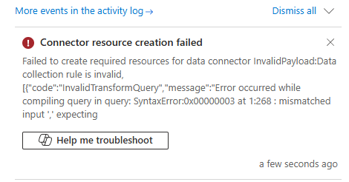

Tried to tweak the KQL query in many forms but it didn’t work. Later through research tested this at Scuba end and came to know that it must be defined in a way **[‘title’]** as this is a reserve word.

There are restrictions in CCP for the reserve words. We can’t define them directly as in the raw log in KQL query. So far observed reserved words are **date, title.**

For example, consider we have column field **title** and while project-rename, it should be defined as with Pascal casing **Title = [‘title’]** in the transform KQL query. Attached the screenshots for reference.

**Duplication Issue:**

For duplication of logs issue, we have defined correct query parameters and pagination after in depth research and understanding of the product documentation.